Student Name: __________________
Class and Section __________________
Total Points (20 pts) __________________
Due: March 21, 2010 before the class

Project: Sorting Animation

CSCI 5520 Rapid Java Application Development
Armstrong Atlantic State University

Problem Description:

Write an animation applet for selection sort, insertion sort, and bubble sort, as shown in the following figures. Create an array of integers 1, 2, ..., 50. Shuffle it randomly. Create a panel to display the array. You should invoke each sort method in a separate thread.

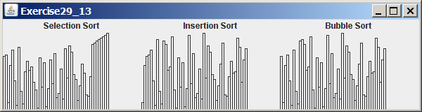
(a) Sorting in progress

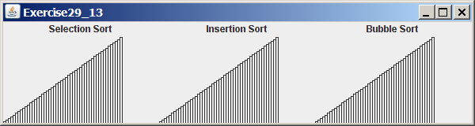
(b) Sorted

Requirements:
Name your program Exercise28_13
(1) Run each sort program in a separate task.
(2) Define a panel class for displaying an int array in a histogram.
(3) After each outer iteration in the sort program, redisplay the histogram.

What to submit?

1. Compile and Submit to LiveLab (you must submit the program regardless whether it complete or incomplete, correct or incorrect)

2. Fill in self-evaluation:

- Can your program display the GUI? _______________
- Can your program sort correctly?
- Can your program redisplay histogram? _______________

